**BUSINESS ANALYTICS USING R - SQL Assignment**

Anamika Jayaraj

2237024

2 MAECO

Submitted to:

Mr. Abdul MR



MA APPLIED ECONOMICS

Department of Economics

School of Social Sciences

(Submitted March 2023)

**SQL Assignment - SQL Murder Mystery**

Given to us on the website:

A crime has taken place and the detective needs your help. The detective gave you the crime scene report, but you somehow lost it. You vaguely remember that the crime was a ​murder​ that occurred sometime on ​Jan.15, 2018​ and that it took place in ​SQL City​. Start by retrieving the corresponding crime scene report from the police department’s database.

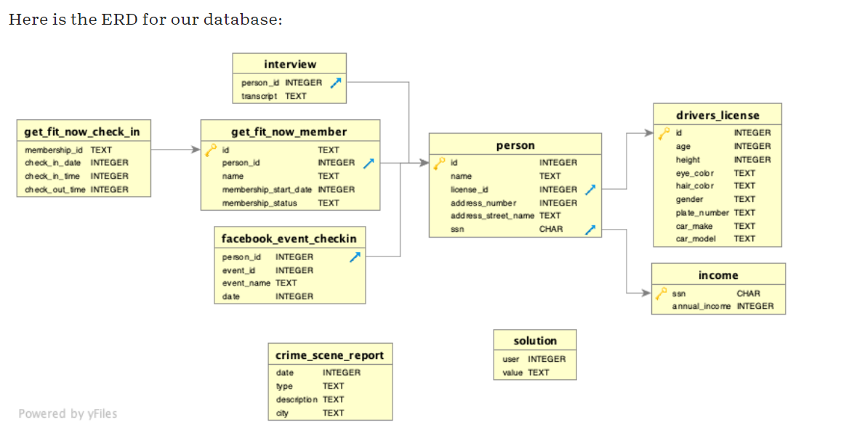

1. To view the whole table available:

SELECT * from sqlite_master

RUN

Results:

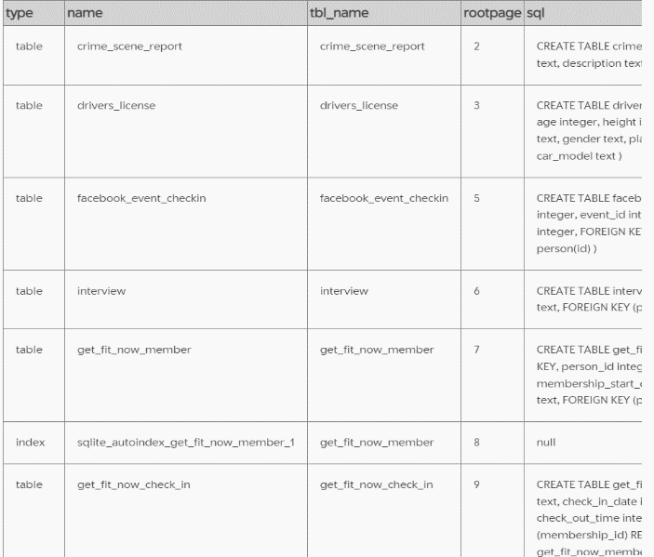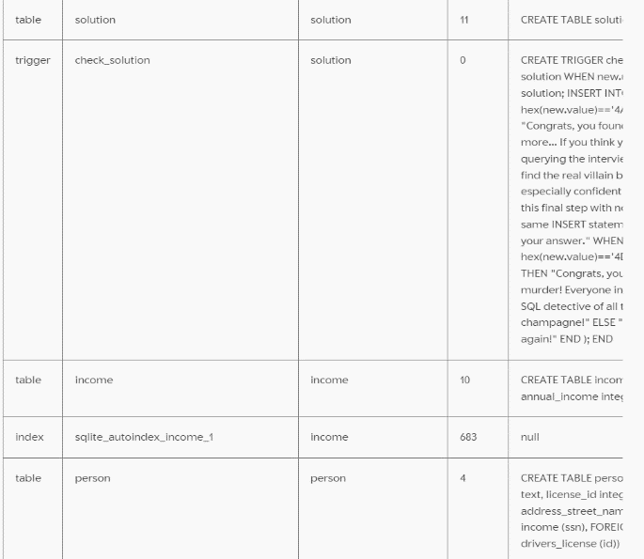

1. To view the table headings/names of the table:

SELECT name

FROM sqlite_master

where type = 'table'

RUN

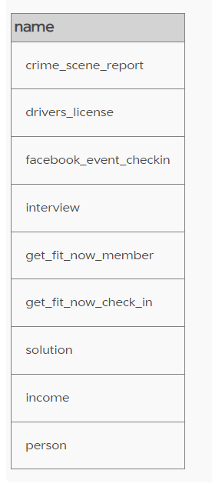

1. To see all the number of murders committed so far:

SELECT count (*)

FROM 'crime_scene_report'

where type = 'murder'

RUN

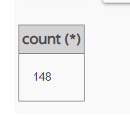

1. To see the murders committed only in SQL City:

SELECT *

FROM 'crime_scene_report'

where type = 'murder'

AND city = 'SQL City';

RUN

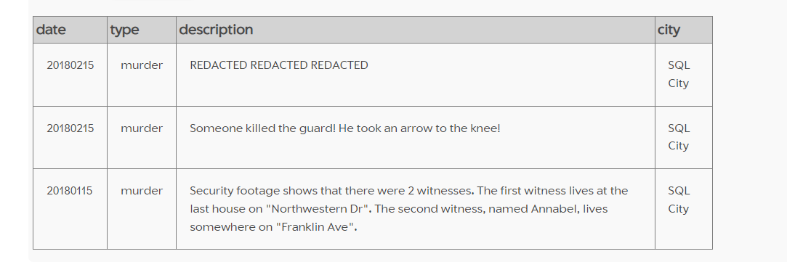

1. To find information on Annabel:

SELECT *

FROM 'person'

WHERE address_street_name = "Franklin Ave"

AND name LIKE "Annabel%"

RUN

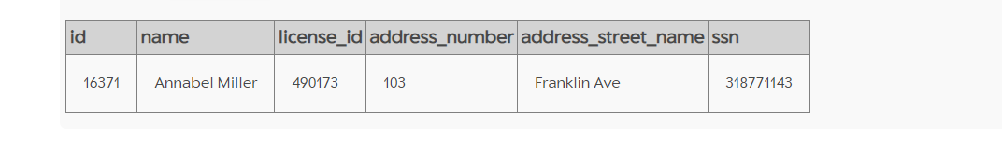

1. To find the person who lives on the last house on Northwestern Dr:

SELECT *

FROM 'person'

WHERE address_street_name = "Northwestern Dr"

Order by address_number desc

RUN

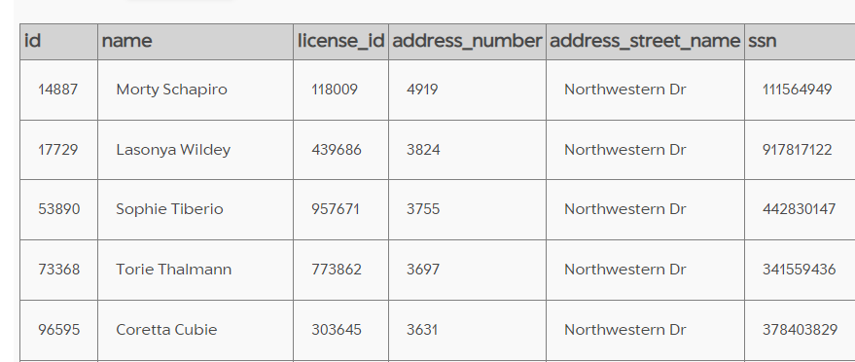

1. To find the interview transcripts of the witnesses:

SELECT person.name, interview.transcript

FROM person

JOIN interview

ON person.id = interview.person_id

WHERE name = "Morty Schapiro" OR name = "Annabel Miller"

RUN

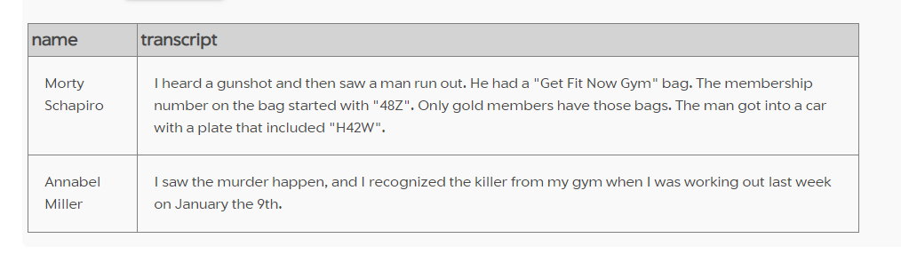

1. To find information of the people who used the Gym on 9th January 2018:

SELECT get_fit_now_member.name, get_fit_now_check_in.membership_id, get_fit_now_check_in.check_in_date

From get_fit_now_member

JOIN get_fit_now_check_in

ON get_fit_now_member.id = get_fit_now_check_in.membership_id

WHERE check_in_date = 20180109

RUN

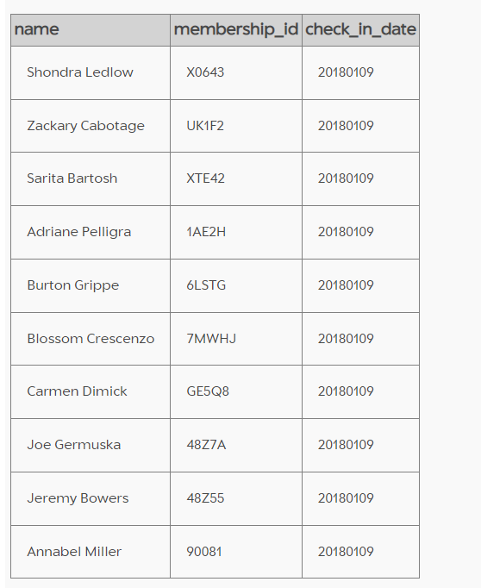

1. To find the Gold members:

SELECT get_fit_now_member.name, get_fit_now_check_in.membership_id,

get_fit_now_check_in.check_in_date

From get_fit_now_member

JOIN get_fit_now_check_in

ON get_fit_now_member.id = get_fit_now_check_in.membership_id

WHERE membership_id LIKE "48Z%"

AND check_in_date = 20180109

RUN

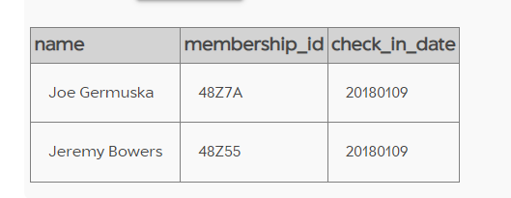

1. To check solution:

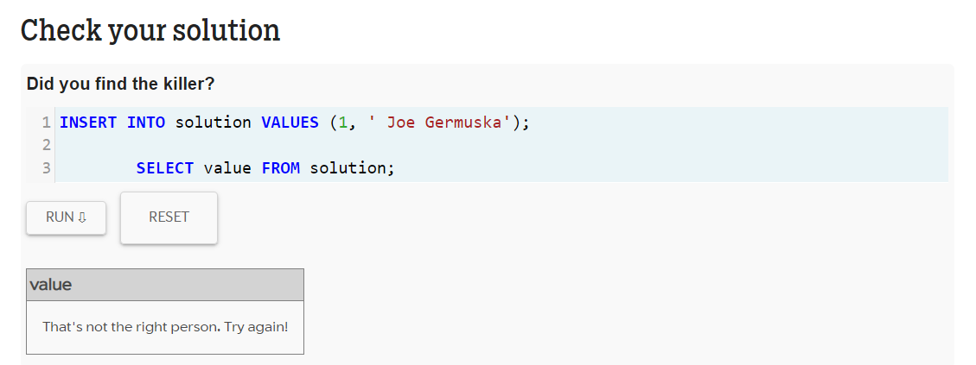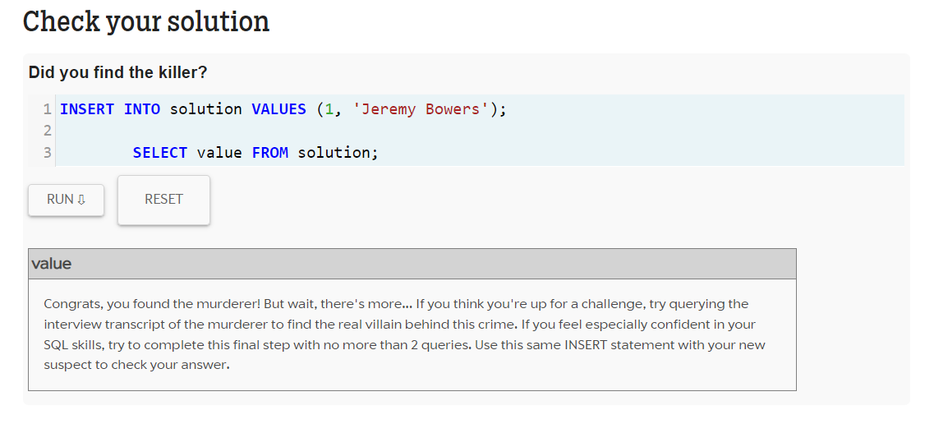

1. To find the real villain:

SELECT person.name, interview.transcript

FROM person

JOIN interview

ON person.id = interview.person_id

WHERE name = "Jeremy Bowers"

RUN

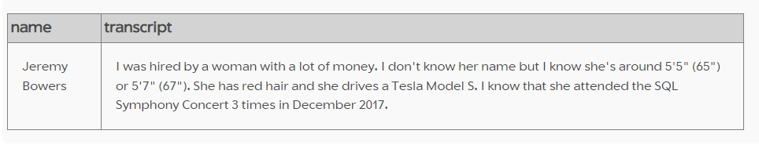

SELECT name, annual_income as income, gender, eye_color as eyes, hair_color as hair,

car_model as car

FROM income i

JOIN person p

ON i.ssn = p.ssn

JOIN drivers_license dl

ON p.license_id = dl.id

WHERE hair = "red"

AND car = "Model S"

order by income desc

RUN

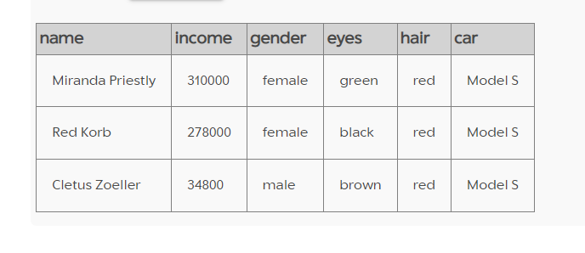

To Check Answer:

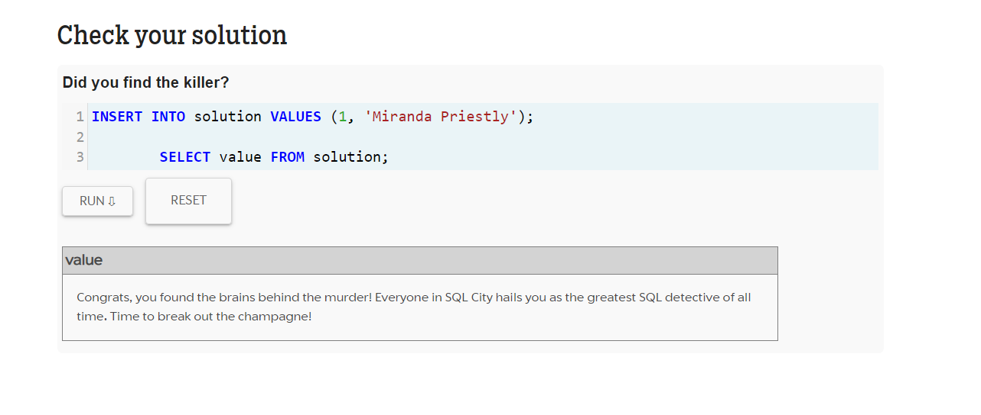

Solution: Jeremy Bowers committed the murder on the orders of Miranda Priestly.